
Name: ______________________________

Full Test (Sections 1 and 2)

Total Time: 44 minutes

Total Marks: 39 marks

Student Result ________/ 39

MATHEMATICS METHODS Unit 1
TEST 1A -2018
Function Definition and Linear Relationships

Calculator Free Section
Time: 17 minutes
Marks: 15 marks

Resources allowed: SCSA Formula Sheet

Instructions to candidates
Show all your working clearly. Your working should be in sufficient detail to allow your answers to be checked readily and for marks to be awarded for reasoning. Incorrect answers given without supporting reasoning cannot be allocated any marks. For any question or part question worth more than two marks, valid working or justification is required to receive full marks. If you repeat any question, ensure that you cancel the answer you do not wish to have marked.

Question 1. [2 marks]
Is the line $4x+ y=8$ parallel, perpendicular, or neither, to the line $4y=x+12$?

Question 2. [1, 2, 2 = 5 marks]
Two points have coordinates $A (-9, -6)$and $B (11, -12).$
- Determine the coordinates of C, the mid-point of $A$ and $B$.

- If $B$ is the mid-point of $A$ and $D$, determine the coordinates of $D$.

- Find the equation of the straight line passing through $(-20, 5)$ and parallel to the line segment$AB$.

Question 3. [1 mark]
Circle the correct answer from the following options.

If $f\left(x\right)=3x^{2}+4$ then $f(-x)$ is equal to:

A 1 B 7 C f(x) D $-3x^{2}+4$

Question 4. [1, 2, 4 = 7 marks]
- Over the restricted domain of $\left\{x∈R:-1≤x≤4\right\}$, determine the corresponding range for

- $f\left(x\right)=-3x+2$

- $f\left(x\right)=-x^{2}+4$

- Complete the table below for the natural domain and range of each function.

FUNCTION | DOMAIN | RANGE
$$f\left(x\right)=\sqrt{2x-8}$$
$$f\left(x\right)=\frac{1}{x-5}+2$$


Name: ____________________________

MATHEMATICS METHODS Unit 1
TEST 1A -2018
Function Definition and Linear Relationships

Calculator Assumed Section
Time: 27 minutes
Marks: 24 marks

Resources allowed:
SCSA Formula Sheet
Up to three Calculators and
One A4 sheet, both sides of notes

Instructions to candidates
Show all your working clearly. Your working should be in sufficient detail to allow your answers to be checked readily and for marks to be awarded for reasoning. Incorrect answers given without supporting reasoning cannot be allocated any marks. For any question or part question worth more than two marks, valid working or justification is required to receive full marks. If you repeat any question, ensure that you cancel the answer you do not wish to have marked.

Question 5. [1, 3 = 4 marks]
Given the lines $L_{1}: 3y=-4x+6$ and $L_{2}: 3x-2y=-21$,

- Determine point $P$, the point of intersection between $L_{1}$ and $L_{2}$.

- Find the equation of the line that is perpendicular to $L_{2}$ passing through point $P$.

Question 6. [3 marks]
Below are four relationships and their matching graph. Which represent functions?
Of those that are functions, state if they are one-to-one or many-to-one.

a) $y=\sqrt{x-2}$ b) $y=2x(x-3)(x+3)$
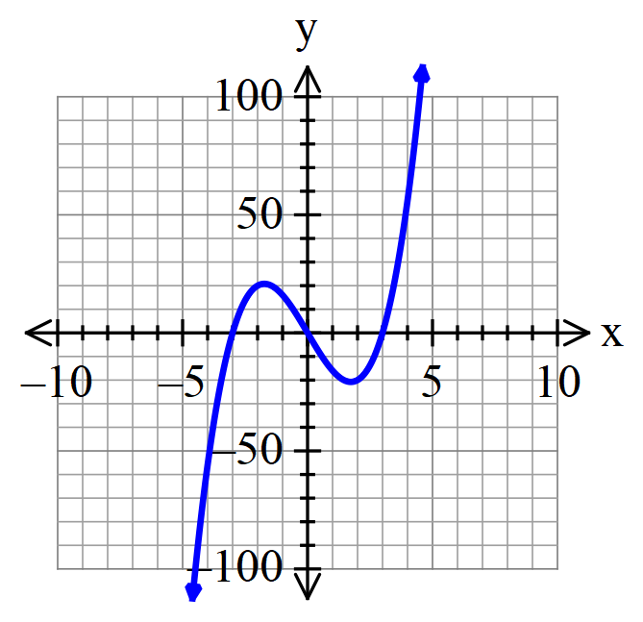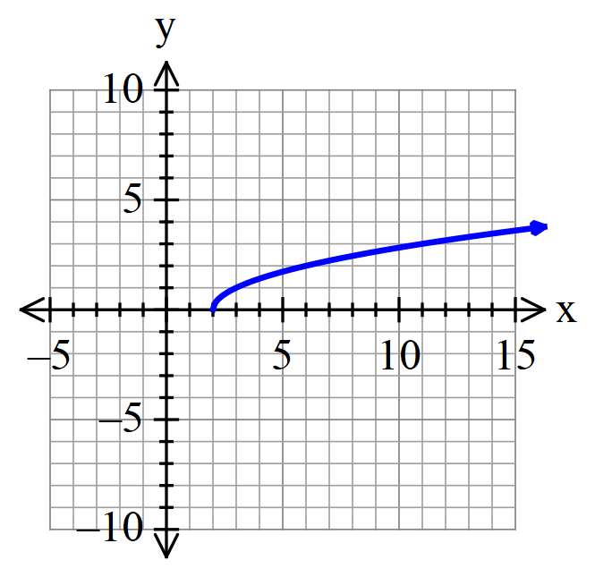

c) $y^{2}+ {(x-3)}^{2} =4$ d) ${y= 2}^{x}-4$
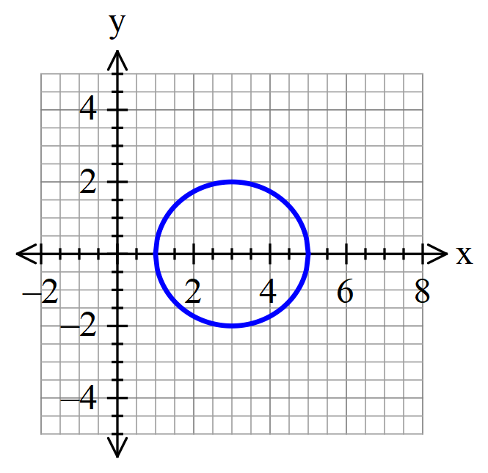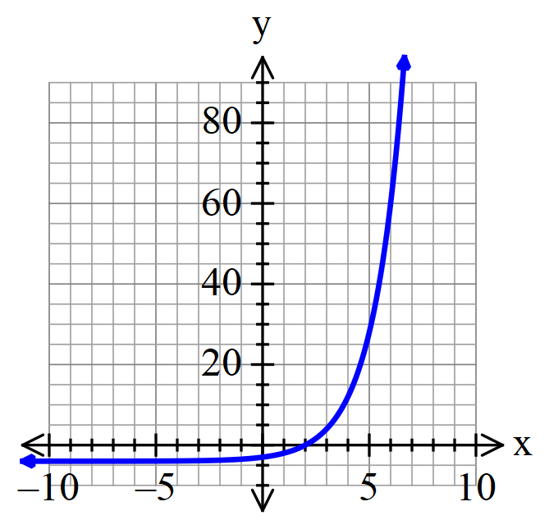

Question 7. [2, 1, 5 = 8 marks]

The points $A\left(-2, 5\right), B\left(2, 3\right), C(1,-4)$ and $D(-4, 1)$ are the vertices of the quadrilateral $ABCD$.

The equation of the diagonal $BD$ is, $y=\frac{1}{3}x+\frac{7}{3}$

- Show that the equation of the diagonal $AC$ is, $y=-3x-1$

- Find point $E$, the point of intersection of the two diagonals.

- Show that triangle ADE is a right angled isosceles triangle.

Question 8. [2, 1, 1 = 4 marks]
A linear relationship exists between the profit $\$P$, when operating a tourist bus and $n$, the number of empty seats.
A graph of the relationship shows the line passing through points, $(n, \$P)$, of (8, 720) and (21, 486).
If the rule is of the form, $P=kn+C$,

- Calculate $k$ and $C$.

- What is the meaning of the constant term?

- What is the number of empty seats if no profit is made?

Question 9. [5 marks]
Find the value(s) of k if $\left(k+2\right)x+3y=4$ is perpendicular to $kx+5y=0$


Name: ________SOLUTIONS______

Full Test (Sections 1 and 2)

Total Time: 44 minutes

Total Marks: 39 marks

Student Result ________/ 39

MATHEMATICS METHODS Unit 1
TEST 1A -2018
Function Definition and Linear Relationships

Calculator Free Section
Time: 17 minutes
Marks: 15 marks

Resources allowed: SCSA Formula Sheet

Instructions to candidates
Show all your working clearly. Your working should be in sufficient detail to allow your answers to be checked readily and for marks to be awarded for reasoning. Incorrect answers given without supporting reasoning cannot be allocated any marks. For any question or part question worth more than two marks, valid working or justification is required to receive full marks. If you repeat any question, ensure that you cancel the answer you do not wish to have marked.

Question 1. [2 marks]
Is the line $4x+ y=8$ parallel, perpendicular, or neither, to the line $4y=x+12$?

$\left(1\right) y=-4x+8$

$\left(2\right) y=\frac{1}{4}x+3$ determines gradient of both line functions

$m_{1}=-\frac{1}{m_{2}}$

$∴Lines are perpendcular$ identifies lines are ⊥

Question 2. [1, 2, 2 = 5 marks]
Two points have coordinates $A (-9, -6)$and $B (11, -12).$
- Determine the coordinates of C, the mid-point of $A$ and $B$.
$\left(\frac{-9+11}{2},\frac{-6+-12}{2}\right)$
C = $(1, -9)$ determines coordinates correctly
- If $B$ is the mid-point of $A$ and $D$, determine the coordinates of $D$.

$(11,-12)=\left(\frac{-9+x_{D}}{2},\frac{-6+y_{D}}{2}\right)$

$$(22,-24)=\left(-9+x_{D}, -6+y_{D}\right)$$

$D=\left(31,-18\right)$ determines each coordinate correctly

- Find the equation of the straight line passing through $(-20, 5)$ and parallel to the line segment$AB$.
$m_{AB}=\frac{-6-(-12)}{-9-11}$

$m=\frac{3}{-20}=-\frac{3}{20}$ determines gradient of line segment AB
$y-y_{1}=m(x-x_{1})$ or $y=-\frac{3}{20}x+c$
$y-5=-\frac{3}{20}\left(x-(-20)\right)$ $5=-\frac{3}{20}(-20)+c$

$y=-\frac{3}{20}x-3+5$ $5=3+c$ $∴c=2$

$y=-\frac{3}{20}x+2$ determines the correct equation

Question 3. [1 mark]
Circle the correct answer from the following options.

If $f\left(x\right)=3x^{2}+4$ then $f(-x)$ is equal to:

A 1 B 7 C f(x) D $-3x^{2}+4$

correct

Question 4. [1, 2, 4 = 7 marks]
- Over the restricted domain of $\left\{x∈R:-1≤x≤4\right\}$, determine the corresponding range for

- $f\left(x\right)=-3x+2$

$\left\{y∈R:-10≤y≤5\right\}$ correct lower and upper bounds

- $f\left(x\right)=-x^{2}+4$

$\left\{y∈R:-12≤y≤4\right\}$ correct lower and upper bounds

- Complete the table below for the natural domain and range of each function.

FUNCTION | DOMAIN | RANGE
$$f\left(x\right)=\sqrt{2x-8}$$ | $\left\{x∈R:x≥4\right\}$ | $\left\{y∈R:y≥0\right\}$
$$f\left(x\right)=\frac{1}{x-5}+2$$ | $\left\{x∈R:x≠5\right\}$ | $\left\{y∈R:y≠2\right\}$


Name: ________SOLUTIONS______

MATHEMATICS METHODS Unit 1
TEST 1A -2018
Function Definition and Linear Relationships

Calculator Assumed Section
Time: 27 minutes
Marks: 24 marks

Resources allowed:
SCSA Formula Sheet
Up to three Calculators and
One A4 sheet, both sides of notes

Instructions to candidates
Show all your working clearly. Your working should be in sufficient detail to allow your answers to be checked readily and for marks to be awarded for reasoning. Incorrect answers given without supporting reasoning cannot be allocated any marks. For any question or part question worth more than two marks, valid working or justification is required to receive full marks. If you repeat any question, ensure that you cancel the answer you do not wish to have marked.

Question 5. [1, 3 = 4 marks]
Given the lines $L_{1}: 3y=-4x+6$ and $L_{2}: 3x-2y=-21$,

- Determine point $P$, the point of intersection between $L_{1}$ and $L_{2}$.

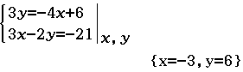

$P=(-3, 6)$ correct

- Find the equation of the line that is perpendicular to $L_{2}$ passing through point $P$.

$3x-2y=-21$

$y=\frac{3}{2}x+\frac{21}{2}$

$m_{L_{2}}=\frac{3}{2}$ correct gradient of $L_{2}$

$m=-\frac{2}{3}$ correct gradient of the line ⊥ to $L_{2}$

$y-y_{1}=m(x-x_{1})$

$y-6=-\frac{2}{3}(x+3)$

$y=-\frac{2}{3}x-2+6$

$y=-\frac{2}{3}x+4$ correct equation (follow through marks if part a) is different)

Question 6. [3 marks]
Below are four relationships and their matching graph. Which represent functions?
Of those that are functions, state if they are one-to-one or many-to-one.

a) $y=\sqrt{x-2}$ b) $y=2x(x-3)(x+3)$


Function: one-to-one correct Function: many-to-one correct

c) $y^{2}+ {(x-3)}^{2} =4$ d) ${y= 2}^{x}-4$


Not a function Function: one-to-one correct

Question 7. [2, 1, 5 = 8 marks]

The points $A\left(-2, 5\right), B\left(2, 3\right), C(1,-4)$ and $D(-4, 1)$ are the vertices of the quadrilateral $ABCD$.

The equation of the diagonal $BD$ is, $y=\frac{1}{3}x+\frac{7}{3}$

- Show that the equation of the diagonal $AC$ is, $y=-3x-1$

$m_{AC}=\frac{y_{2} -{ y}_{1}}{x_{2} - x_{1}}=\frac{-4-5}{1-(-2)}=\frac{-9}{3}=-3$ correct use of gradient formula

$y-y_{1}=m(x-x_{1})$

$y-5=-3(x+2)$

$y=-3x-6+5$

$y=-3x-1$ correctly solves for the y-intercept (0, -1)

- Find point $E$, the point of intersection of the two diagonals.

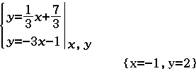

$E=(-1, 2)$ correct

- Show that triangle ADE is a right angled isosceles triangle.

Since points $A, E$ and $C$ are collinear and points $B, E$ and $D$ are collinear, then

$m_{AE}=m_{AC}=-3$

$m_{ED}=m_{BD}=\frac{1}{3}$ states the gradients of the sides AE and DE

Since $m_{AE}×m_{ED}=-1$ then $AE$ ⊥ $DE$ forming a right angle at vertex $E$ of the triangle.

shows the sides AE and DE form a right angle at vertex E

$d_{AE}=\sqrt{{\left(-2-(-1)\right)}^{2}+{\left(5-2\right)}^{2}}=\sqrt{1+9}=\sqrt{10}$ units

correct use of distance between two points formula

$d_{DE}=\sqrt{{\left(-2-(-1)\right)}^{2}+{\left(5-2\right)}^{2}}=\sqrt{1+9}=\sqrt{10}$ units

correct use of distance between two points formula

Since lengths $AE=DE$ and $AE$ ⊥ $DE$, then triangle $ADE$ is a right isosceles triangle
coherent state of proof

Question 8. [2, 1, 1 = 4 marks]
A linear relationship exists between the profit $\$P$, when operating a tourist bus and $n$, the number of empty seats.
A graph of the relationship shows the line passing through points, $(n, \$P)$, of (8, 720) and (21, 486).
If the rule is of the form, $P=kn+C$,

- Calculate $k$ and $C$.

$k=\frac{(720-486)}{(8-21)}=-18$ correct value for k

$P=-18n+C$

$720=-18(8)+C$

$C = 864$ correct value for C

- What is the meaning of the constant term?

The constant term represents the profit when no seats are empty. coherent answer

- What is the number of empty seats if no profit is made?

Solving $0=-18n+864$

$n=48$

No profit is made when 48 seats are empty. correct

Question 9. [5 marks]
Find the value(s) of k if $\left(k+2\right)x+3y=4$ is perpendicular to $kx+5y=0$

$3y= -\left(k+2\right)x+4$ and $5y=-kx$

$y= \frac{-\left(k+2\right) }{3}x+ \frac{4}{3}$ $y=-\frac{k}{5}x$

correctly determines the gradient of each line in terms of k

$-\frac{\left(k+2\right)}{3}= \frac{5}{k}$ equates the gradient of one line with the negative reciprocal of the other

$k\left(k+2\right)=-15$

$k^{2 }+2k+15=0$

$(k+5)(k+3)=0$

$k=-5 or k=-3$ correctly solves the resulting quadratic for the two solutions

